**Software Requirements Specification**

IDENTIFY CAR WASH SERVICES PROJECT

|  |  |  |  |
| --- | --- | --- | --- |
|  | Prepared By | Reviewed By | Approved By |
| Name | Sneha Odeyar | Devathilagai |  |
| Role | Intern | Batch Trainer |  |

**Table of Contents**

Table of Contents…………………………………………………………..….......II

1. Introduction…………………………………………………………………..…1

1.1 Intended Audience……………………………………………….......1

1.2 Project Scope…………………………...……………………………1

2. Overall Description…………………………………………….……………….1

2.1 Operating Environment……………………...……………………....1

3. Requirements……………………………………………………………...…….1

3.1Login………………………………………………………………….2

3.1.1Description………………………………………………....2

3.1.2 Functional Requirements……..…………………………...2

**1. Introduction**

Coursera is an online learning website. We are taking and testing one functionality of that website (i.e.) Searching for Web Development courses. and also extract the look for the language learning

**1.1 Intended Audience**

Business Unit (BU) SME

Academy coach

Technical Trainer

**1.2 Project Scope**

This document defines at a functional level the business activities that are encompassed by the system and the rules that apply to them. It also encompasses some of the key high and low level technical requirements of the system.

It draws heavily on both proposed Framework and Business Rules and the Technical Architecture documents. The scope of the detailed analysis project phase specifies that this document will include.

* Classification of requirements according to their functional areas.
* A description of each process in the system, including their inputs, outputs, and data transformation rules.

**2. Overall Description**

**2.1 Operating Environment**

* Windows operating system
* Web application

**3. Requirements**

This part of the requirements document serves to present the "Doorstep Car Wash Services" of the application and also we need to get the Service Names and Amount Details, And capture the Address of all the State and City Combinations.

**3.1.1 Functional Requirements**

**3.1.1.1 Req0001**

**Req0001a-**The user selects “Car” from select service type and “SUV” from Subcategory dropdowns and Click on “Go for It” Button.

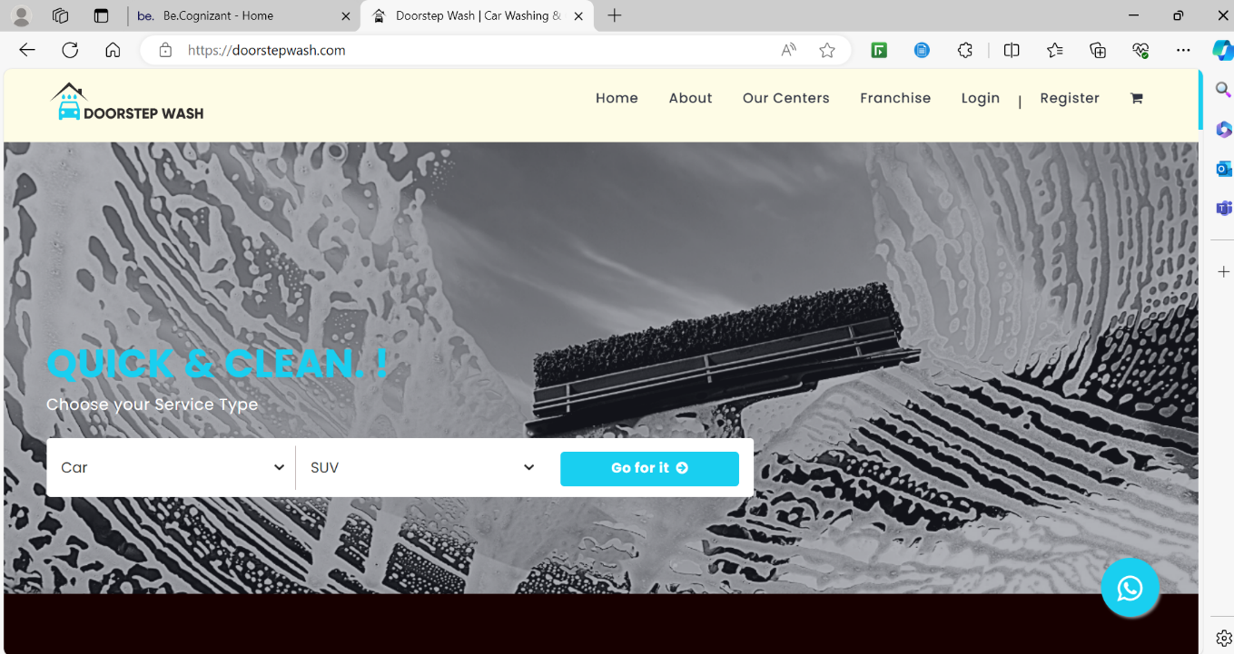

**Req0001b**- The user navigates to next page which contains all the service names and respective amount details.

**Req0001c-**The user captures all the “Service Names” and “Amount”.

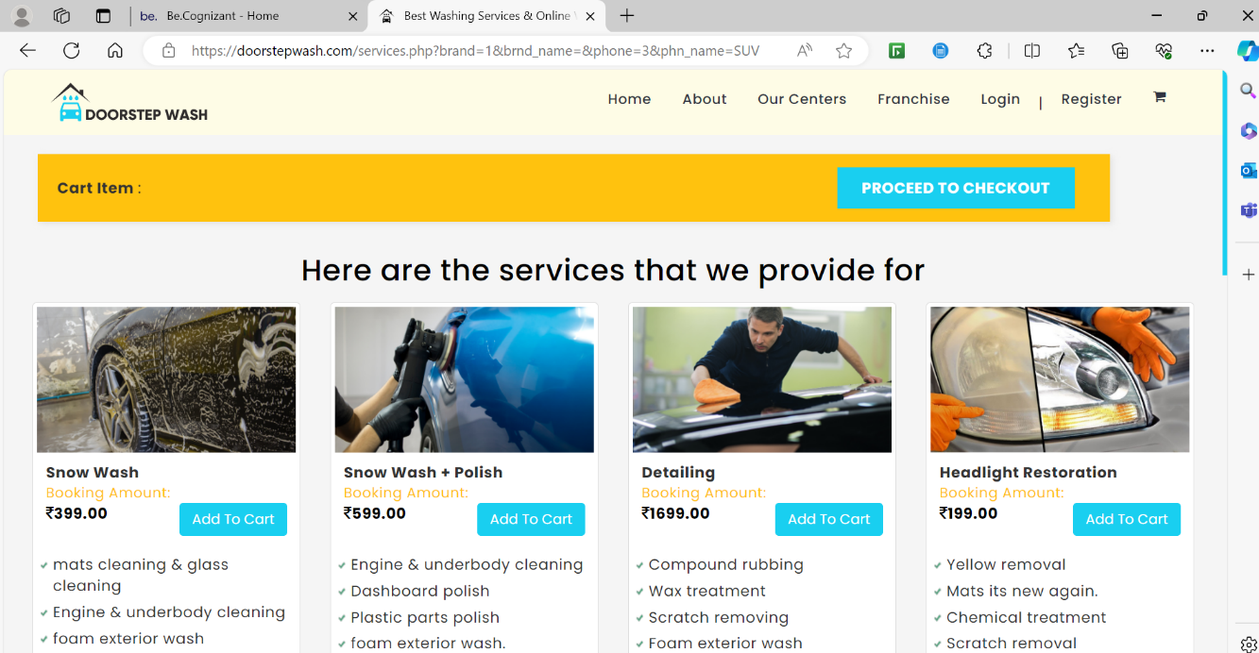

**3.1.1.2 Req0002**

**Req0002a**- The user clicks “Register” option from the webpage.

**Req0002b-** The user fills the Signup form with all details and with Invalid Email.

**Req0002c-** The user clicks on Signup Button.

**Req0002d-** The error message will pop up and user capture the error message.

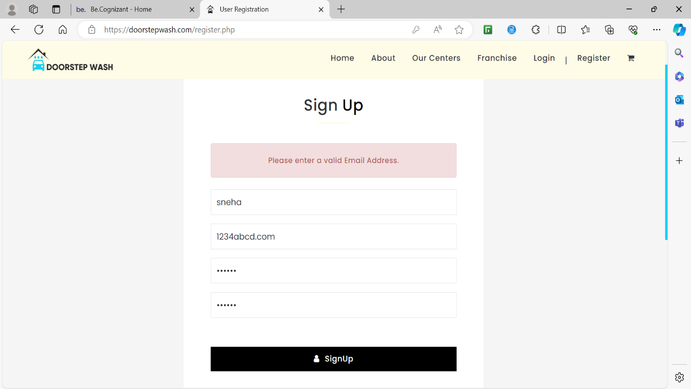

**3.1.2.3 Req0003**

**Req0003a**- The user clicks on home icon logo and navigate back to home page.

**Req0003b-** The user clicks on Our Centers option.

**Req0003c-** The user selects 3 Combination of State and City from “select your state”, “select your city” dropdowns and click on Search Button.

**Req0003d-** The user Captures all the Address of the available services.



